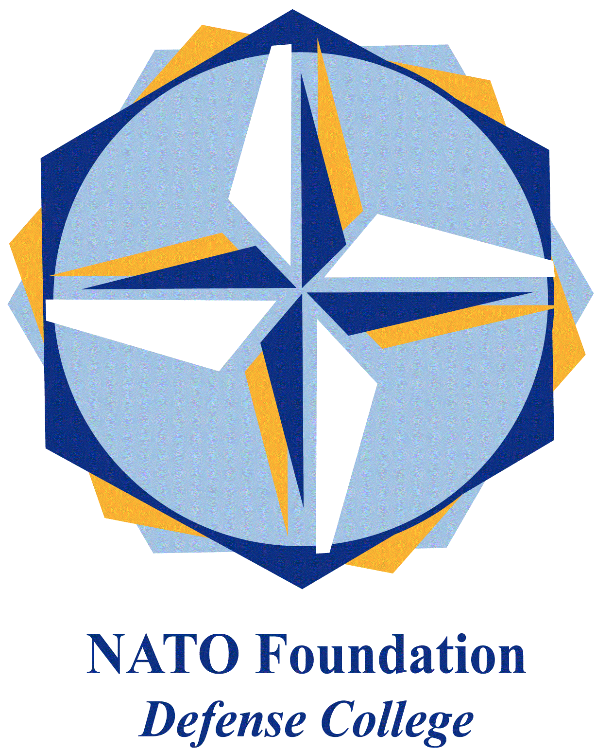
NATO DEFENSE COLLEGE FOUNDATION
STRATEGIC TRENDS
October 2015
LEVANT
The Syrian file, re-loaded
As Syria enters its fifth year of war, more than a dozen countries came together in Vienna on October 30th to find a solution to the bloodiest crisis the Middle East has seen in decades. In addition to the United States, Russia, Saudi Arabia, and Turkey, the Vienna meeting included Egypt, Jordan, and Lebanon, as well as EU Foreign Policy chief Federica Mogherini, European countries involved in the Syrian file, and, for the first time, Iran. The inclusion of Iran – the biggest sponsor of the Assad regime with Russia - in the talks, previously blocked by the US, is significant, mostly as it provides the opportunity to deal head-on with the real issue of contention, namely, the destiny of President Bashar al-Assad.
The form of an hypothetical new regime will have to take into account that the majority of Syrians are Sunnis, while a reasonable settlement cannot allow a Sunni domination and the exclusion of minorities, including Alawites. Rumour has it that a solution similar to the Taif Accord in Lebanon is being discussed, whereby names of strong Sunni figures are being considered for the post of Prime Minister, who would have expanded powers, while the President will continue to be an Alawite. At an official level, the idea of maintaining the fundamental structures of the Alawi regime emerges from the reading of the Vienna Final Communiqué which pushes for a secular Syria, a characteristic that clearly refers to the incumbent regime and does not apply to any of the opposition groups currently engaged in the country. The same Communiqué pushes for the establishment of a political process mediated at a United Nations level, and elections open to all Syrians, including those in diaspora.
Another idea being discussed, and pushed for by Saudi Arabia, is to prepare a Sunni-led force in Syria to substitute the regular army. Turkey is proposing the Free Syrian Army (FSA) as one possibility, which evidently shows why this proposal is highly controversial. Indeed, Russia and Iran will not accept any solution that sidelines their interests, and it is not even clear whether those would be safeguarded in a reshuffle of the Alawite regime. As a matter of fact, Bashar al Assad has managed to concentrate all the power and relations on himself and his very tight magic circle, none of whom would be accepted as his successor by the opposite front.
Surely, the military involvement of Russia, which began in the first days of October, has affected the strategic balance on the ground, making it clear that any development must take into account Moscow’s position. Moreover, in a brilliant public relations move, Vladimir Putin’s announcement of his boots-on-the-ground actions against terrorism, has won him some support within the public opinion, especially in comparison to the apparent lack of consistency of the US administration. For this reason, we could say that Moscow’s deployment has pushed the United States to raise its own stakes again, as it became clear when President Barack Obama announced he would send Special Forces on the ground in Syria – or, better, increase their number, as small teams have been conducting special operations in Syria at least since 2012.
What is clear is that these deployments do not help the cause of Syria’s re-unification: the country is now divided on the ground, the regime controlling one-third of the country as it was established after WWII, the Kurds controlling the north and ISIS controlling the central-eastern part. Indeed it is hard to envision a central government that is going to be able to gain and - most of all retain - the territory that was considered to be modern Syria.

